GEMA Education
Competition Registrations — 2026 vs 2025 Performance Summary
Period compared: January 1 – September 4, both years
Prepared by: Ankita Daweshar

What Management Should Know
Overall registrations across all GEMA competitions are up 19.4% year-over-year (1,800 → 2,150 registrations) for the identical Jan 1 – Sep 4 window in both years. Every competition grew this year — none declined — though growth rates vary widely by competition, and the most recent four weeks show some notable shifts in momentum worth flagging to leadership.

Key Observations
- Total registrations grew 19.4% year-over-year (1,800 in 2025 → 2,150 in 2026), a gain of 350 registrations over the same calendar period.
- All eight competitions are ahead of last year's pace — the growth is broad-based, not carried by one or two events.
- Top 3 fastest-growing: Student Speaker Competition (+32.9%), International Coding Olympiad (+26.1%), and International Science Olympiad (+25.1%).
- Slowest-growing 3: AI & Robotics Challenge (+10.0%), Winter Painting Competition (+11.6%), and International Mathematics Olympiad (+14.9%) — still positive, but lagging the portfolio average.
- Momentum shift: Young Innovators Challenge is up only +15.8% for the full period but registrations roughly doubled (+125%) in just the last 4 weeks — a late surge worth capitalizing on with extra promotion before the window closes.
- Conversely, International Science Olympiad and International School Olympiad — both strong performers overall — have nearly flattened or slipped in the last 4 weeks (momentum gap of -5.9pp and -3.1pp), suggesting their early-year push has faded.

Competition-Wise Performance
Competition | 2025 | 2026 | Change | % Change
Student Speaker Competition | 170 | 226 | +56 | +32.9%
International Coding Olympiad | 295 | 372 | +77 | +26.1%
International Science Olympiad | 227 | 284 | +57 | +25.1%
International School Olympiad | 218 | 261 | +43 | +19.7%
Young Innovators Challenge | 209 | 242 | +33 | +15.8%
International Mathematics Olympiad | 268 | 308 | +40 | +14.9%
Winter Painting Competition | 164 | 183 | +19 | +11.6%
AI & Robotics Challenge | 249 | 274 | +25 | +10.0%
TOTAL | 1,800 | 2,150 | +350 | +19.4%

Recommendations
- Investigate what is driving the Student Speaker Competition and International Coding Olympiad surges (channel, timing, partner schools) and replicate the approach for the slower performers.
- Give Young Innovators Challenge a short-term promotional push now, while it is accelerating, to convert momentum into registrations before the period closes.
- Review outreach for International Science and School Olympiads — both are past their peak growth phase and may benefit from a second promotional wave.
- Treat AI & Robotics Challenge, Winter Painting Competition, and International Mathematics Olympiad as priority areas for the next campaign cycle, given they lag the portfolio's average growth rate.

Data Notes
Figures reflect cleaned registration data: duplicate entries, test/placeholder records, and inconsistent competition and school name variants were removed or standardized before analysis. September figures reflect a partial month (data through Sep 4) in both years, not an actual decline.

Dashboard — Overview
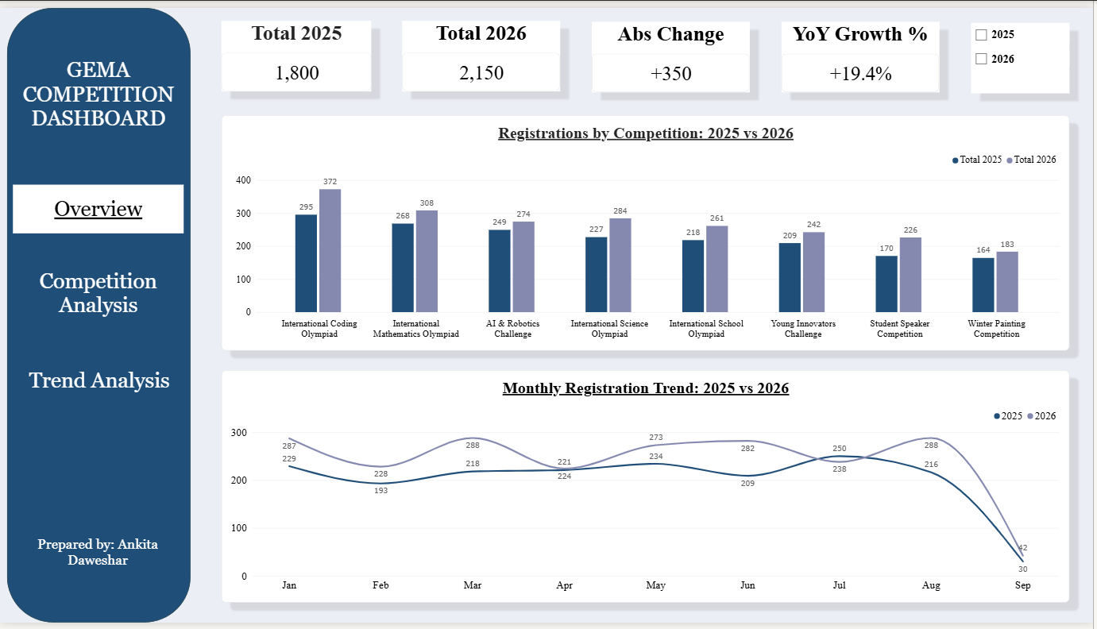
Page 1: KPI summary, competition comparison, and monthly registration trend

Dashboard — Competition Analysis
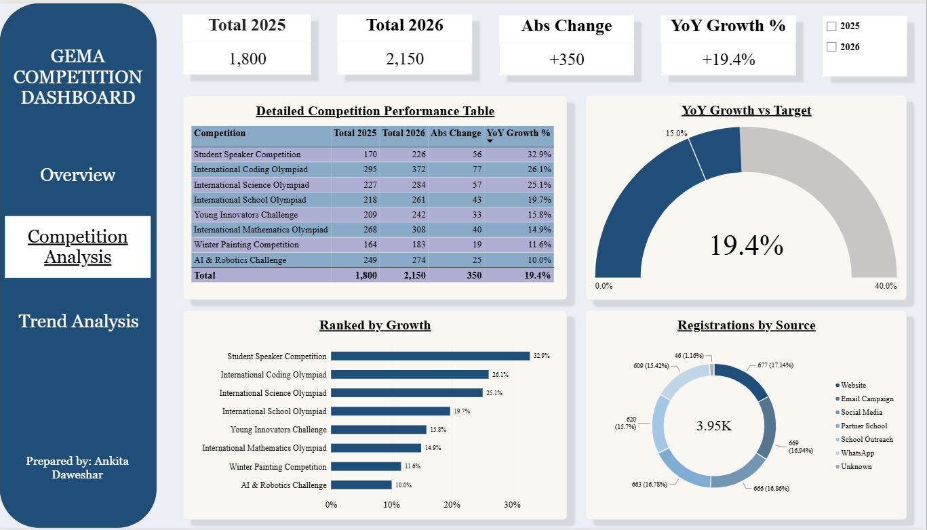
Page 2: Detailed performance table, growth ranking, target gauge, and source breakdown

Dashboard — Trend Analysis
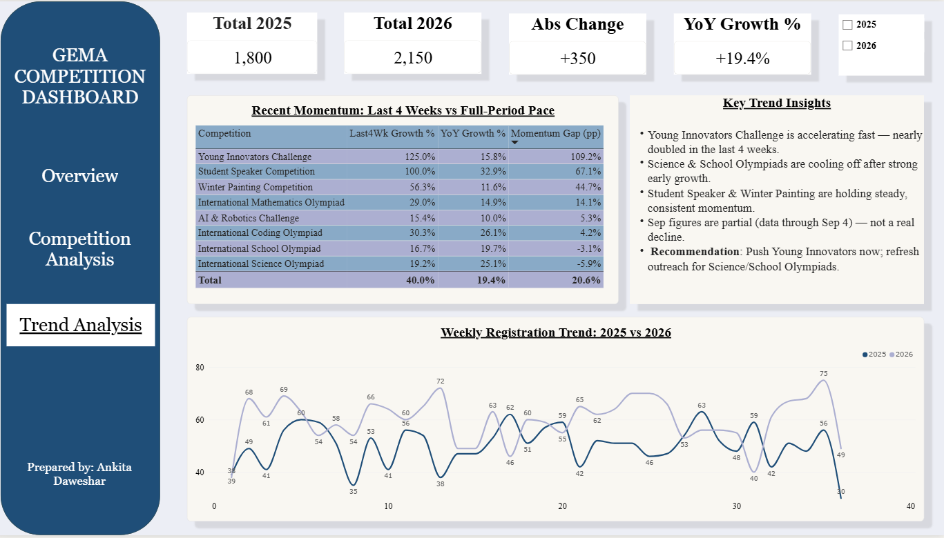
Page 3: Recent momentum vs full-period pace, key trend insights, and weekly registration trend

